­­­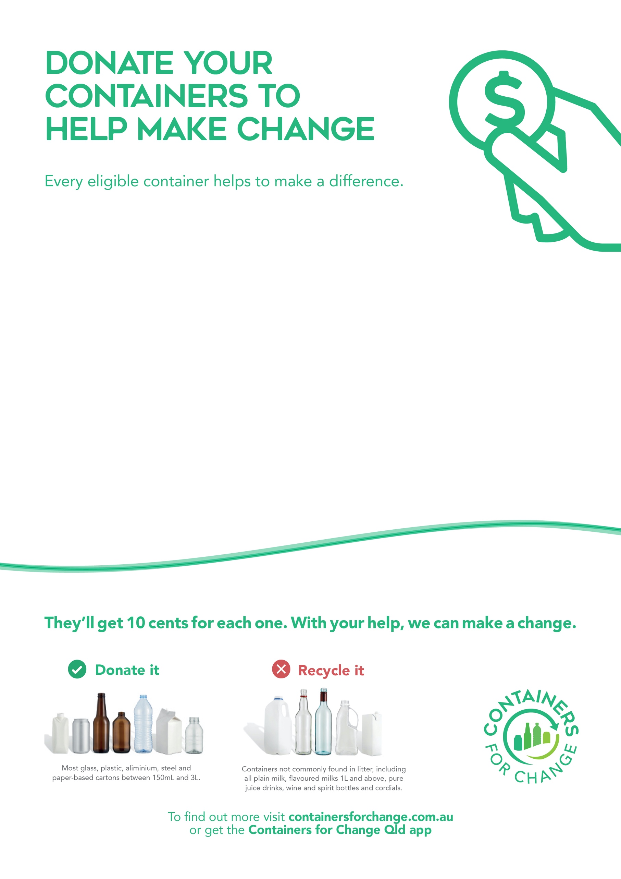­­­

Hi there,

I’m collecting used containers to help <Cause name> to raise <$xxxx> for <cause information> through Containers for Change.

Containers for Change is a state-wide recycling scheme that enables charities and community groups who participate in the scheme to fundraise for their cause.

Every eligible container collected is worth 10 cents, which can really add up! So I’m asking friends and neighbours if they could also save their containers to be collected and donated to <Cause name>.

If I could ask you to please save your containers, I’ll come by to collect any containers you’ve managed to collect and take them down to donate to <insert charity/community group name>.

Thanks very much for your help (and containers),

<insert name>  
<insert contact details>­